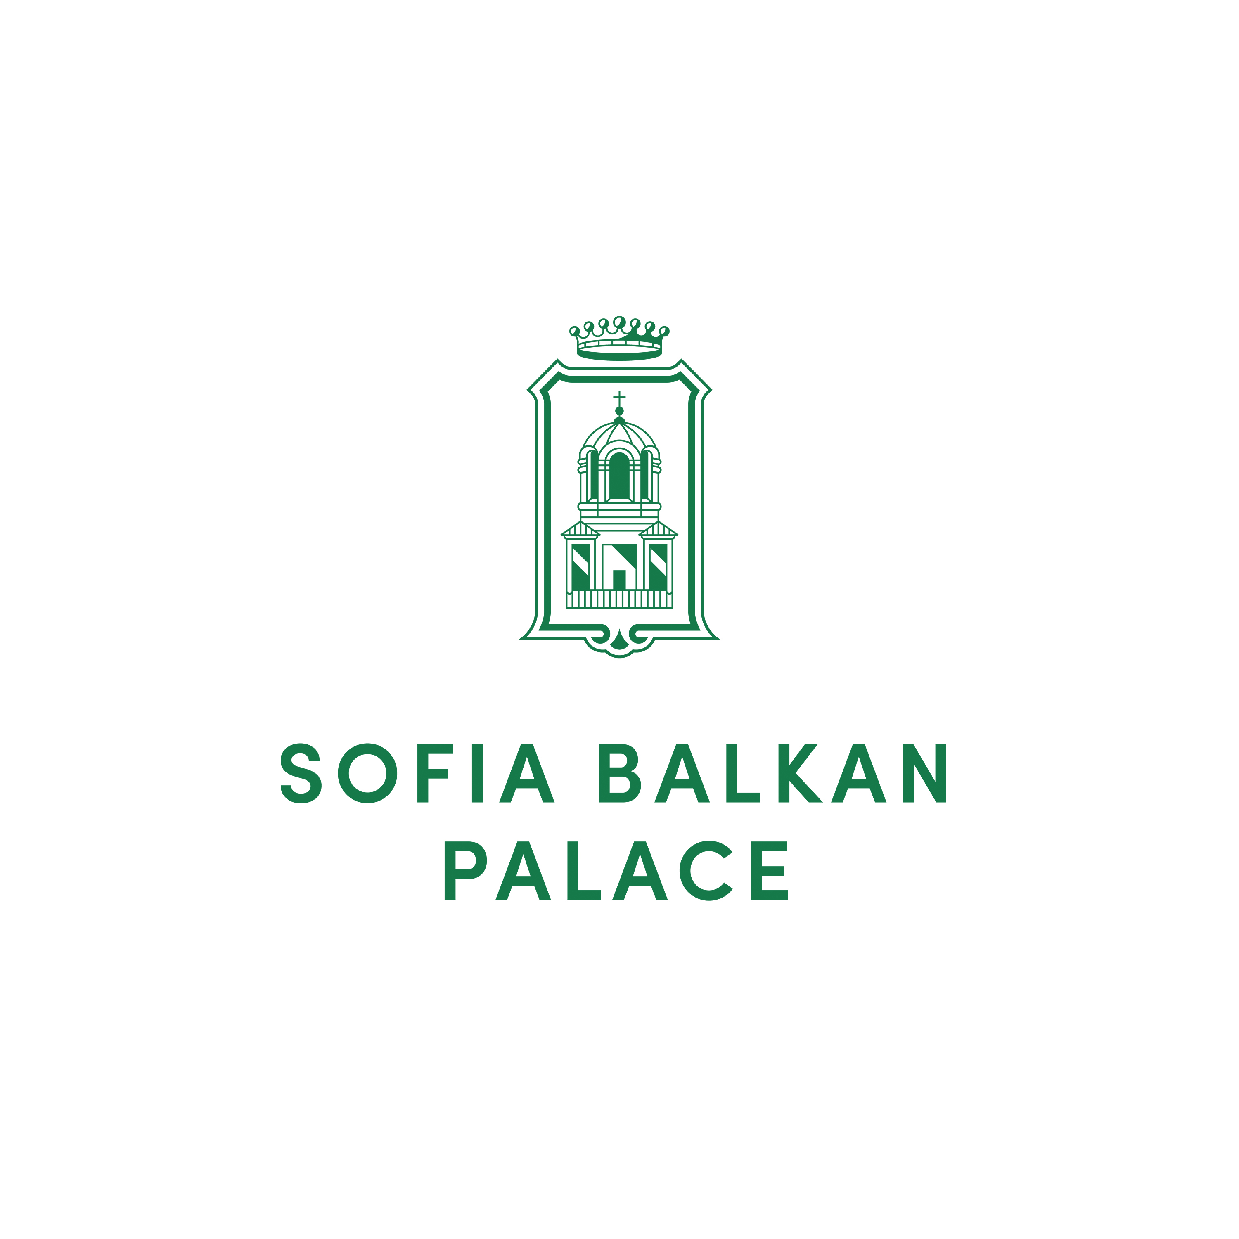

RESERVATION FORM
BULGARIAN SOCIETY OF CARDIOLOGY
15-17 November 2024

In order to book a room at Sofia Balkan Palace, please complete the details below and e-mail the form to our e-mail address below:

Sofia Balkan Palace
e-mail: evelin.beshkova@sofiabalkan.net

Phone: (359) (2) 937 8787
Family name:____________________________First name:_____________________

Company:_____________________________________________________________

Tel:____________________Fax:____________________ E-mail:________________

Arrival date: Departure date:

Cross the room type you require, indicate the total number of rooms and nights required

Deluxe King Single room EUR 120, - Deluxe King Double room EUR 130, -

Total nights:__________________________ No. of rooms:_________________________

Rates are quoted per room, per night, inclusive of buffet breakfast and 9%V.A.T.
EUR 0.67 Tourist tax per person per night will be charged additionally as Tourist tax.

Please indicate the method of payment and guarantee reservation with credit card details:

Credit card name:_______________________ Number:________________________

Expiry date:___________________________ Signature:_______________________

Cancellation policy:
- One night's room revenue will be charged for each room cancelled after 29th of October 2024.
- Guestroom Cancellation between 4 to 0 days prior to arrival, no-show or early departure: All cancelled guestrooms will be charged at full amount for the full duration of the agreed stay.

DEADLINE FOR RESERVATIONS IS OCTOBER 29th 2024
After this date all unsold rooms will be released and all additional reservations will be subject to availability.

